NAME : SHAH FAISAL

ROLL NO : 23I-0058

SECTION : BSE – 4A

OS LAB 03

BSSE SPRING 2026

LAB 03
1.echo -e "Shah Faisal \n 22 \n Black "
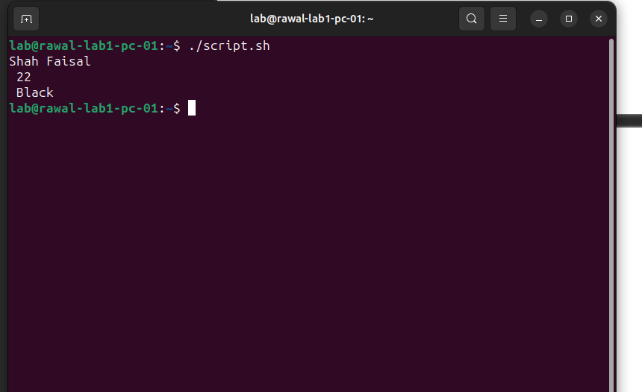
2.#!/bin/bash
num=10

if [ $num -ge 0 ]; then
echo "Positive"
else
echo "Negative"
fi
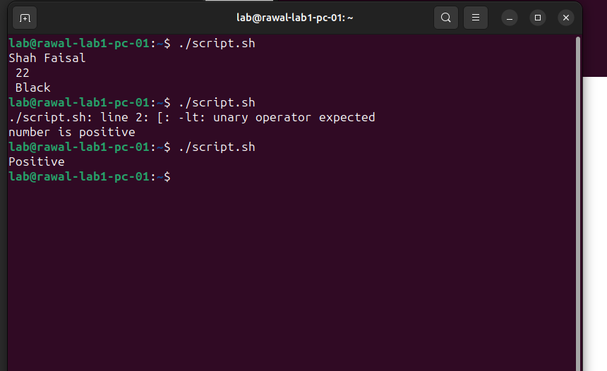
3.#!/bin/bash
num=15

if [ $num -lt 10 ]; then
echo "Small"
elif [ $num -le 20 ]; then
echo "Medium"
else
echo "Large"
fi

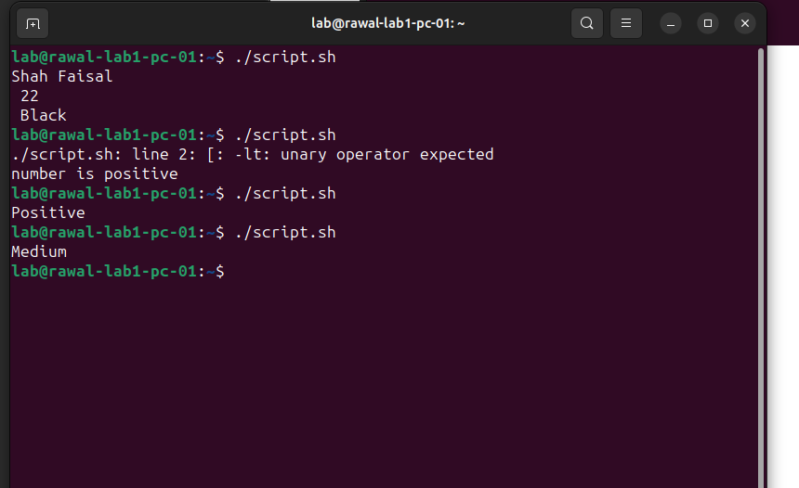
4.for i in {1..5}
do
echo $i
done
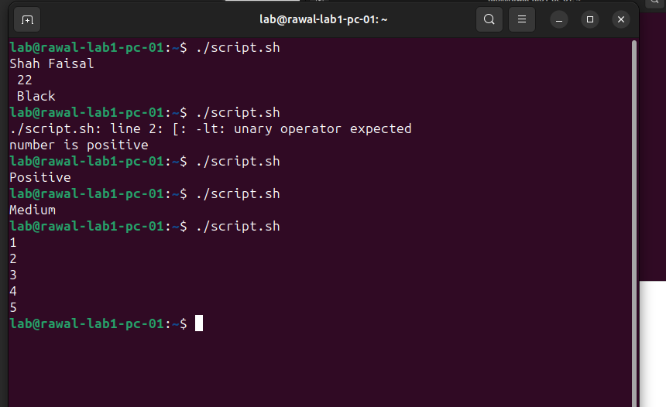
5.count=1
while [ $count -le 5 ]
do
echo $count
count=$((count +1))
done

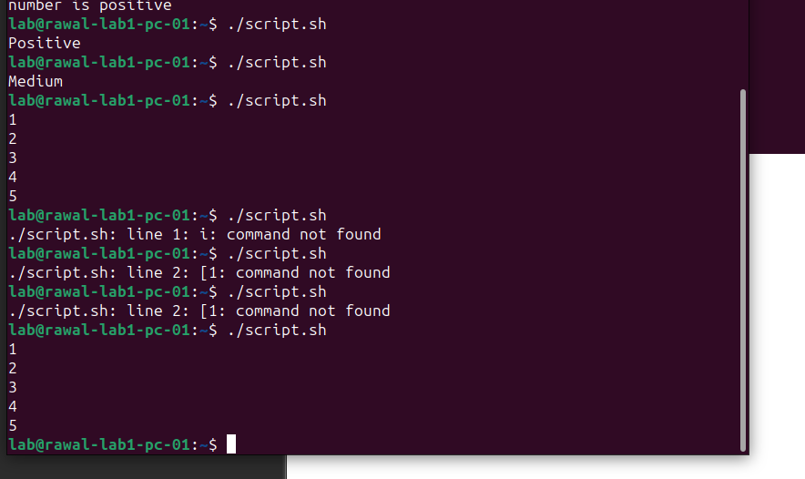
6.a=1
b=2
sum=0
sum=$((a+b))
echo "$sum"

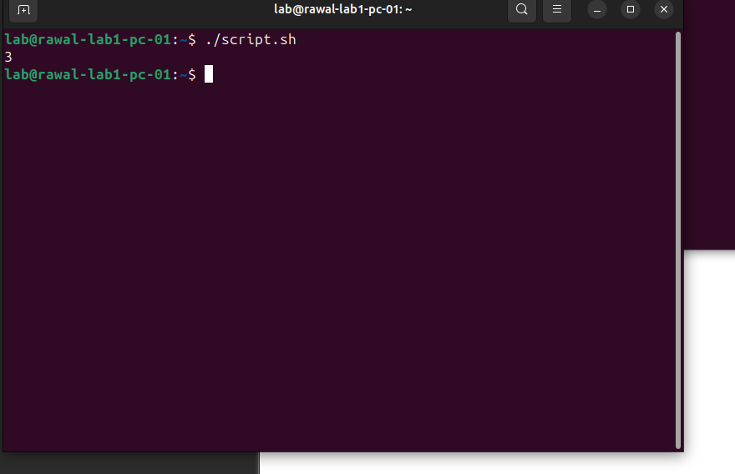
7.str=""
if [ -n "$str'" ]; then
echo "String is empty"
else
echo "String is not empty"
fi

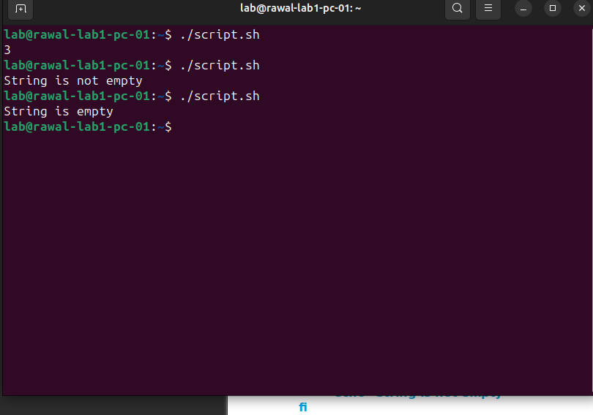

8.#!/bin/bash
file="/home/lab/sohaib.txt"

if [ -f "$file" ] && [ -r "$file" ]; then
echo "File exists and is readable"
else
echo "File not readable"
fi
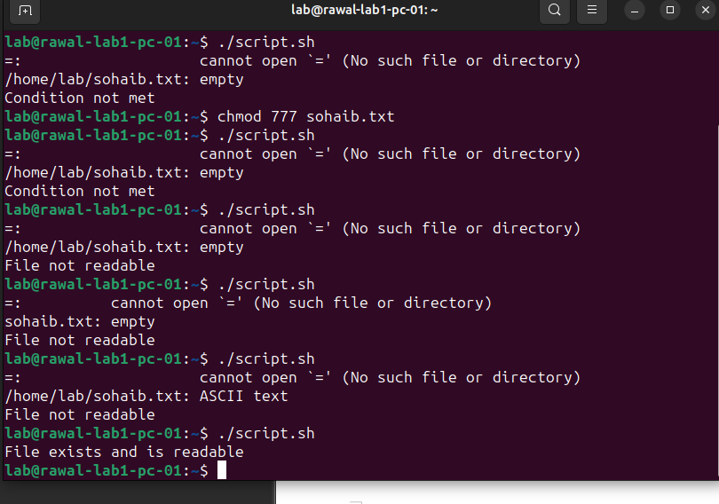
9.file="/home/lab/sohaib.txt"

if [ -f "$file" ] && [ -w "$file" ]; then
echo "File exists and is writable"
else
echo "Condition not met"
fi

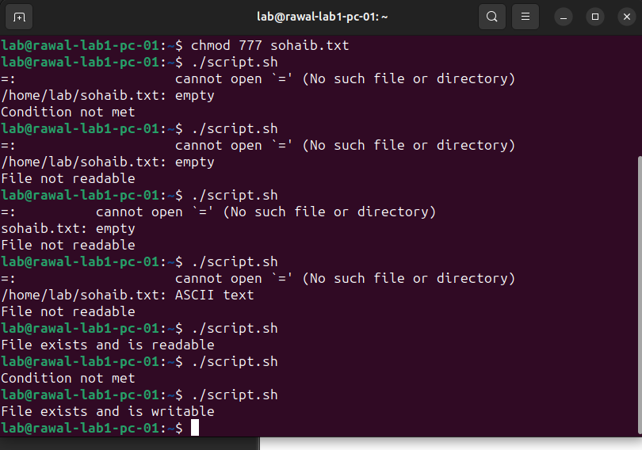
10.dir="/home/lab/task2"

if [ ! -d "$dir" ]; then
echo "Directory does not exist"
else
echo "Directory exist"
fi

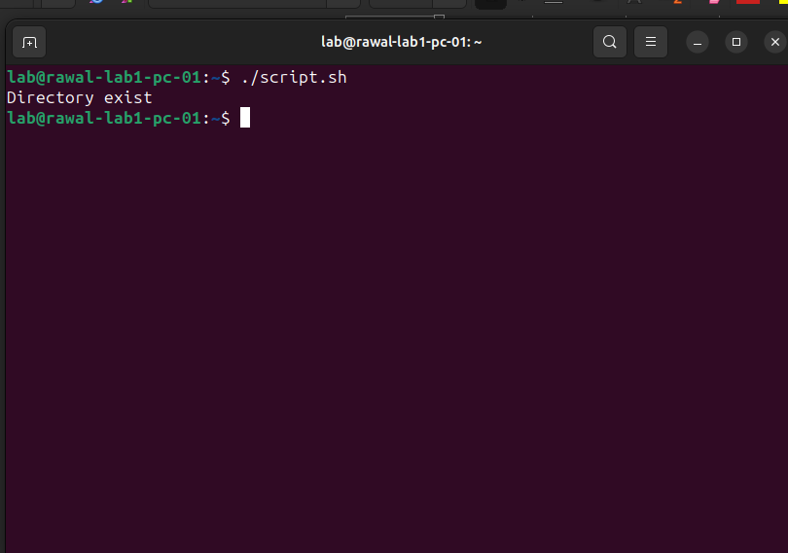

11.#!/bin/bash
num1=-15
if [ $num1 -lt 0 ]; then
echo "Negative"
elif [ $num1 -eq 0 ]; then
echo "Zero"
elif [ $num1 -le 10 ]; then
echo "Small Positive"
else
echo "Large Positive"
fi

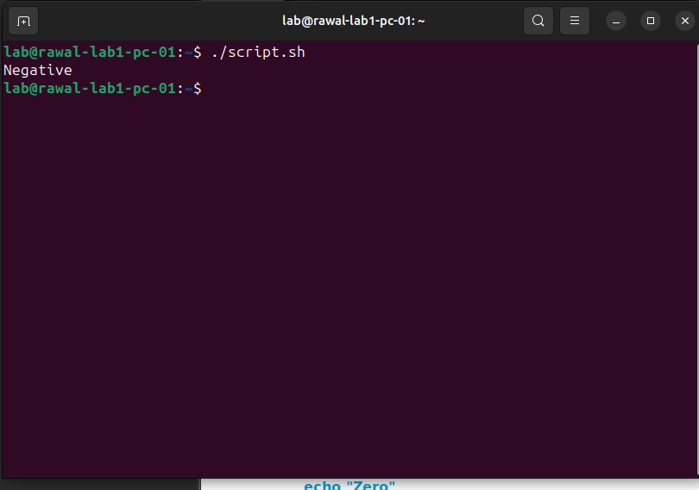

12.file="/home/lab/sohaib.txt"

if [ -r "$file" ] && [ -x "$file" ]; then
echo "File readable and is exectuable"
else
echo "Condition not met"
fi
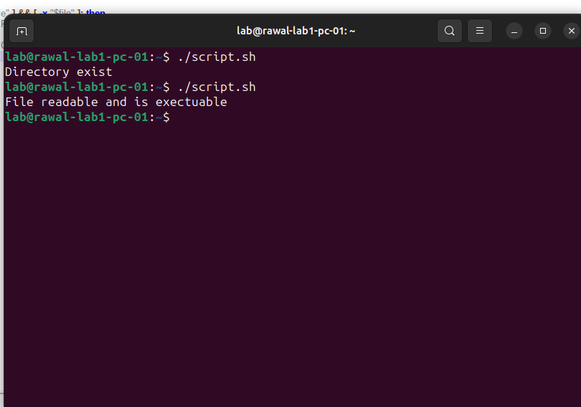
13.file="/home/lab/sohaib.txt"

if [ -r "$file" ] || [ -w "$file" ]; then
echo "File readable or writable"
else
echo "Condition not met"
fi

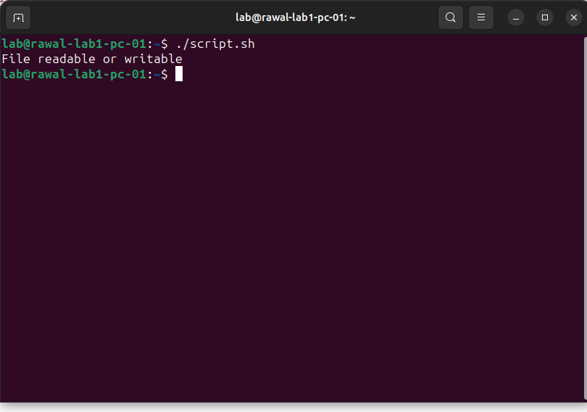
14.for i in {1..10}
do
if [ $((i%2)) -eq 0 ]; then
echo "$i is Even"
else
echo "$i is Odd"
fi
done

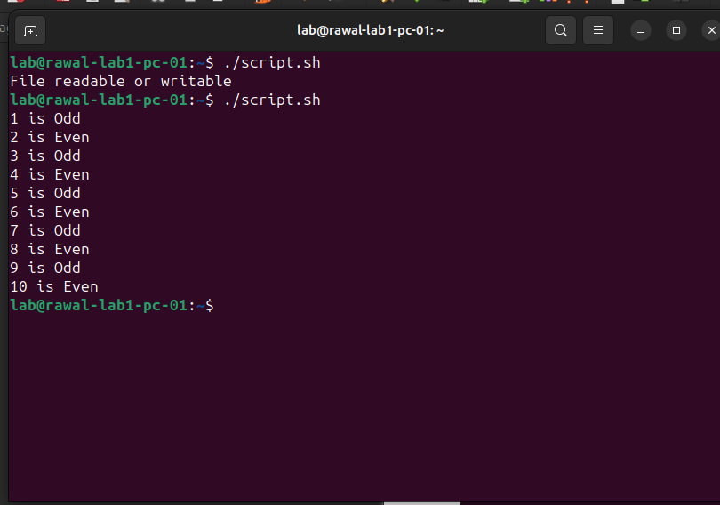
15.i=1
while [ $i -le 10 ]
do
if [ $i -eq 5 ]; then
break
fi
echo $i
i=$((i+1))
done
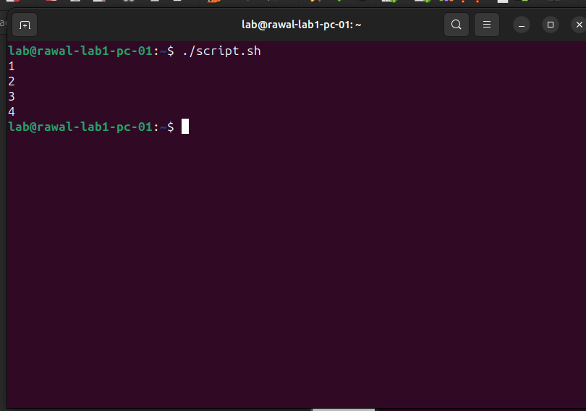
16.dir="/home/lab/task2"
file="/home/lab/sohaib.txt"

if [ -d "$dir" -a -w "$dir" ] -o [ -f "$file" -a -r "$file" ]; then
echo "Condition satisfied"
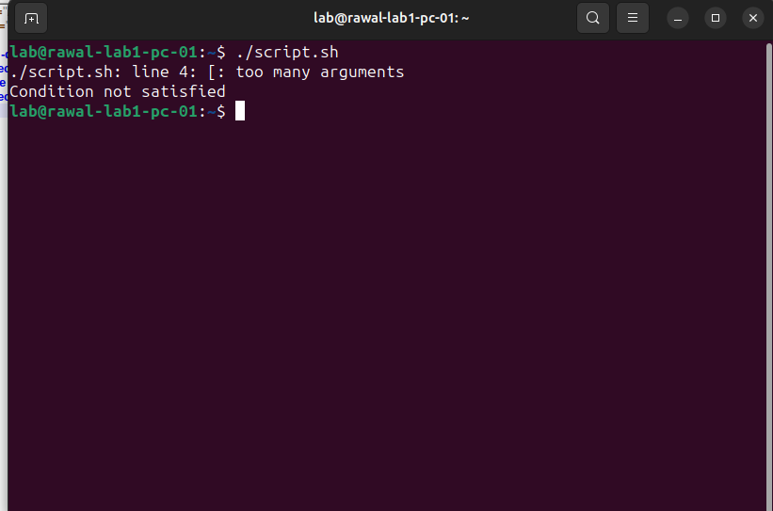
else
echo "Condition not satisfied"
fi

17.for i in {1..10}
do
if [ $i -eq 7 ]; then
continue
fi
echo $i
done

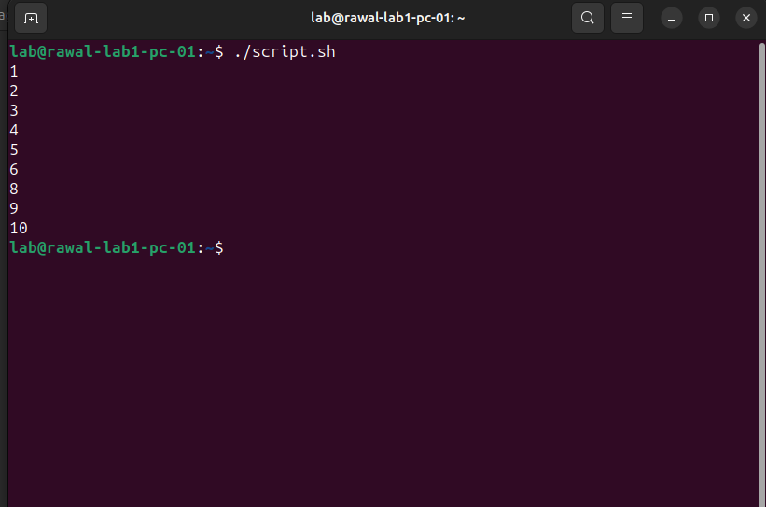

18.while true
do
echo "Running..."
read -p "Type stop to exit: " input
if [ "$input" = "stop" ]; then
break
fi
done

